Test Case: tc001_SPX_Dev5_Crear_Nueva_Linea_Requisicion_Spot_Tipo_Cobro_CC
Step 1 - Enter username and password and click to button Enter : Credentials Entered
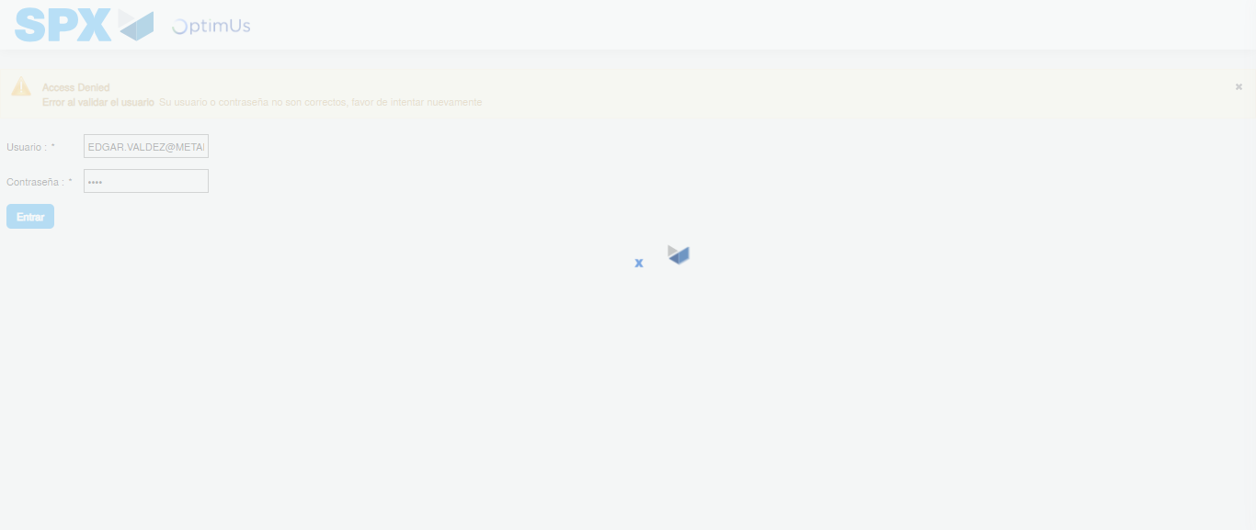Image file-name: QC_Testing-tc001_SPX_Dev5_Crear_Nueva_Linea_Requisicion_Spot_Tipo_Cobro_CC-1781314521503

Step 2 - Select to UEN and Access to Spot Buy Requisitions : UEN Correctly selected and Correct access
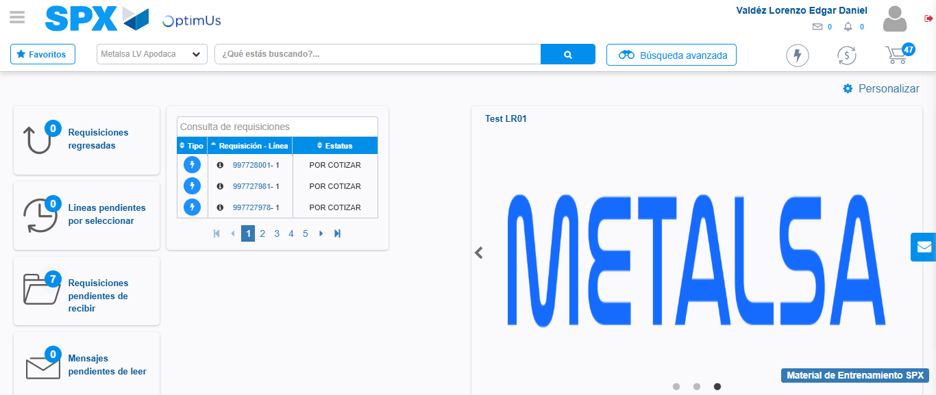Image file-name: QC_Testing-tc001_SPX_Dev5_Crear_Nueva_Linea_Requisicion_Spot_Tipo_Cobro_CC-1781314546574

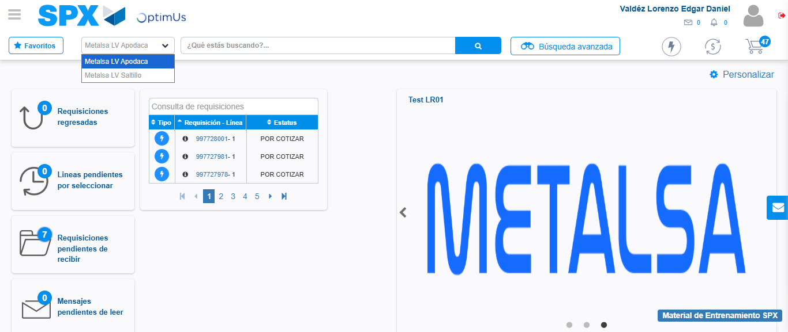Image file-name: QC_Testing-tc001_SPX_Dev5_Crear_Nueva_Linea_Requisicion_Spot_Tipo_Cobro_CC-1781314549136

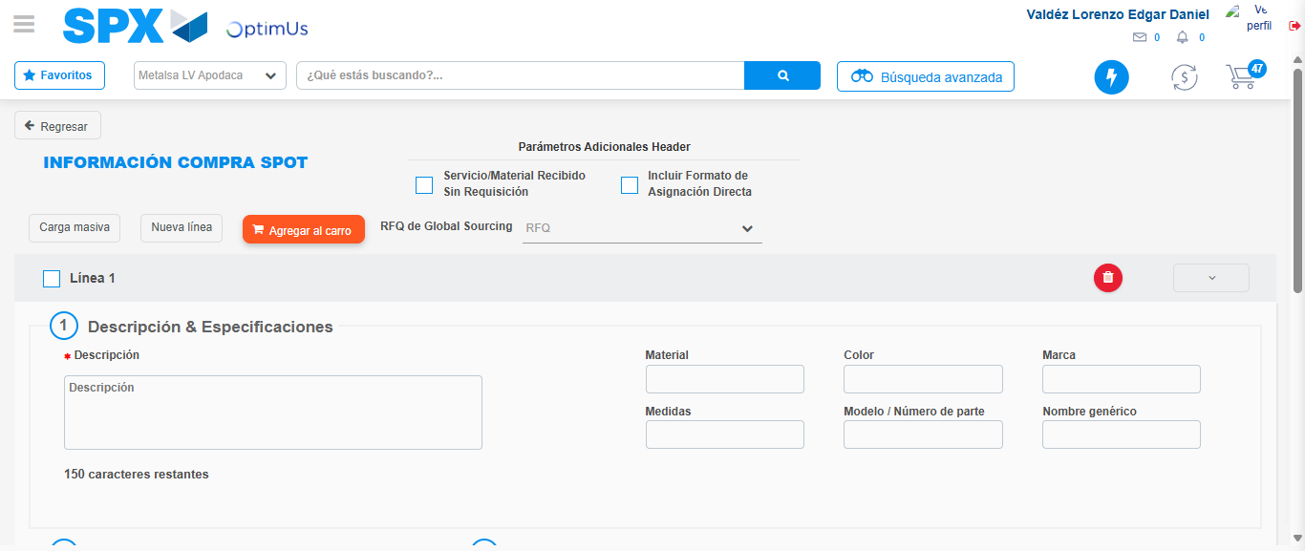Image file-name: QC_Testing-tc001_SPX_Dev5_Crear_Nueva_Linea_Requisicion_Spot_Tipo_Cobro_CC-1781314585667

Step 3 - Data Capture Spot Buy Requisition: Data captured correctly
Image file-name: QC_Testing-tc001_SPX_Dev5_Crear_Nueva_Linea_Requisicion_Spot_Tipo_Cobro_CC-1781314585885

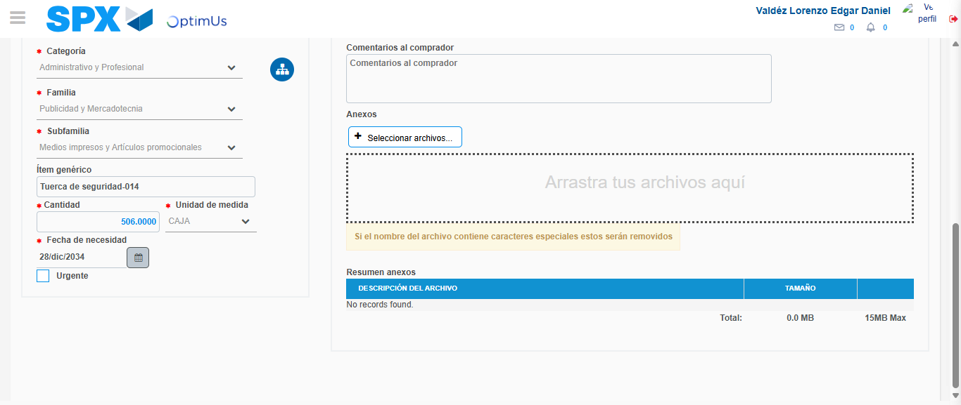Image file-name: QC_Testing-tc001_SPX_Dev5_Crear_Nueva_Linea_Requisicion_Spot_Tipo_Cobro_CC-1781314595370

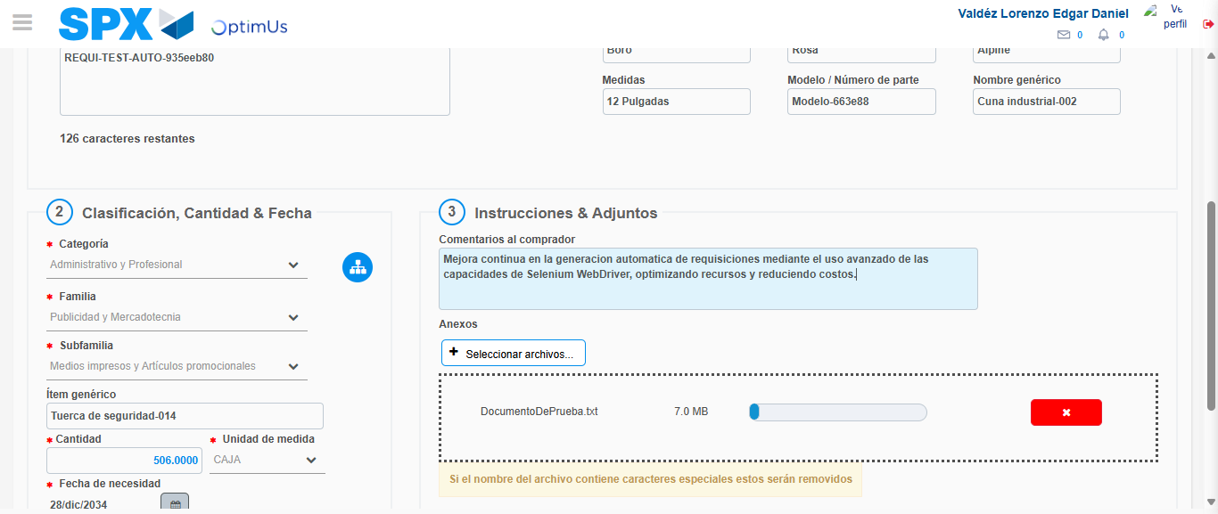Image file-name: QC_Testing-tc001_SPX_Dev5_Crear_Nueva_Linea_Requisicion_Spot_Tipo_Cobro_CC-1781314596351

Step 4 - Add new line and data capture second line: Line add correctly
Image file-name: QC_Testing-tc001_SPX_Dev5_Crear_Nueva_Linea_Requisicion_Spot_Tipo_Cobro_CC-1781314585885

Image file-name: QC_Testing-tc001_SPX_Dev5_Crear_Nueva_Linea_Requisicion_Spot_Tipo_Cobro_CC-1781314595370

Image file-name: QC_Testing-tc001_SPX_Dev5_Crear_Nueva_Linea_Requisicion_Spot_Tipo_Cobro_CC-1781314596351

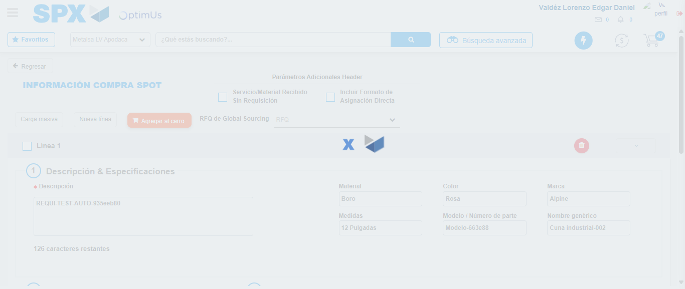Image file-name: QC_Testing-tc001_SPX_Dev5_Crear_Nueva_Linea_Requisicion_Spot_Tipo_Cobro_CC-1781314598682

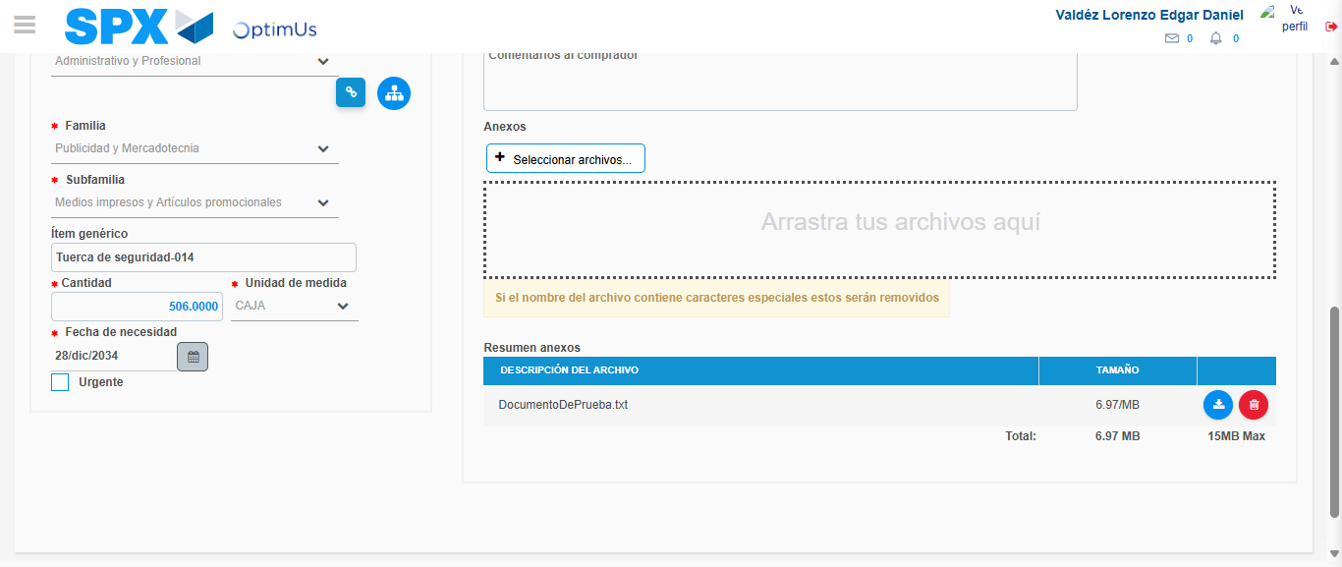Image file-name: QC_Testing-tc001_SPX_Dev5_Crear_Nueva_Linea_Requisicion_Spot_Tipo_Cobro_CC-1781314610891

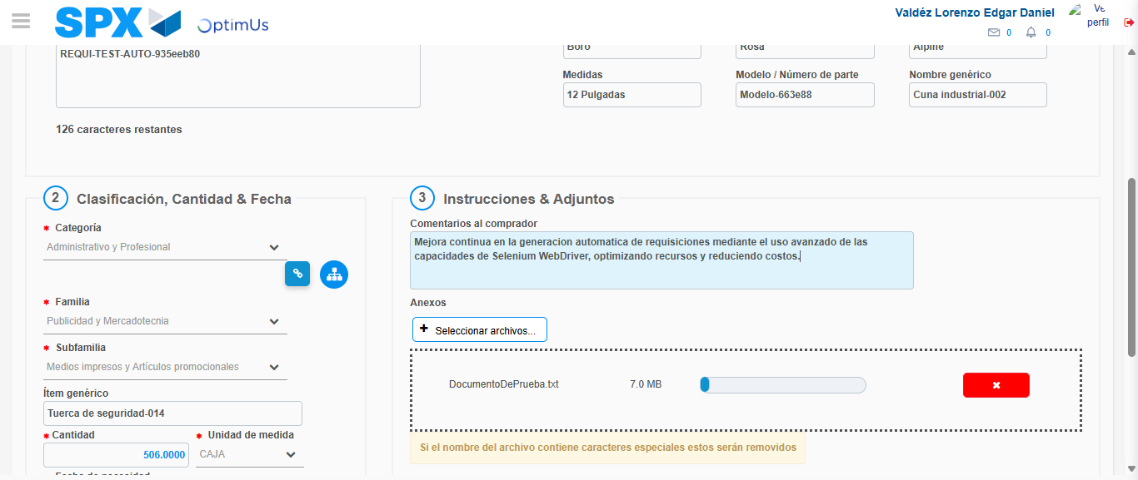Image file-name: QC_Testing-tc001_SPX_Dev5_Crear_Nueva_Linea_Requisicion_Spot_Tipo_Cobro_CC-1781314611659

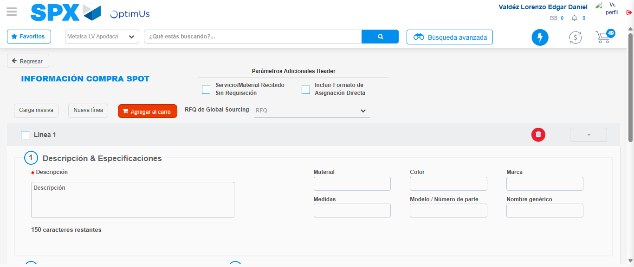Image file-name: QC_Testing-tc001_SPX_Dev5_Crear_Nueva_Linea_Requisicion_Spot_Tipo_Cobro_CC-1781314621207

Step 5 - Select to Requisition: Requisition Correctly selected
Image file-name: QC_Testing-tc001_SPX_Dev5_Crear_Nueva_Linea_Requisicion_Spot_Tipo_Cobro_CC-1781314621374

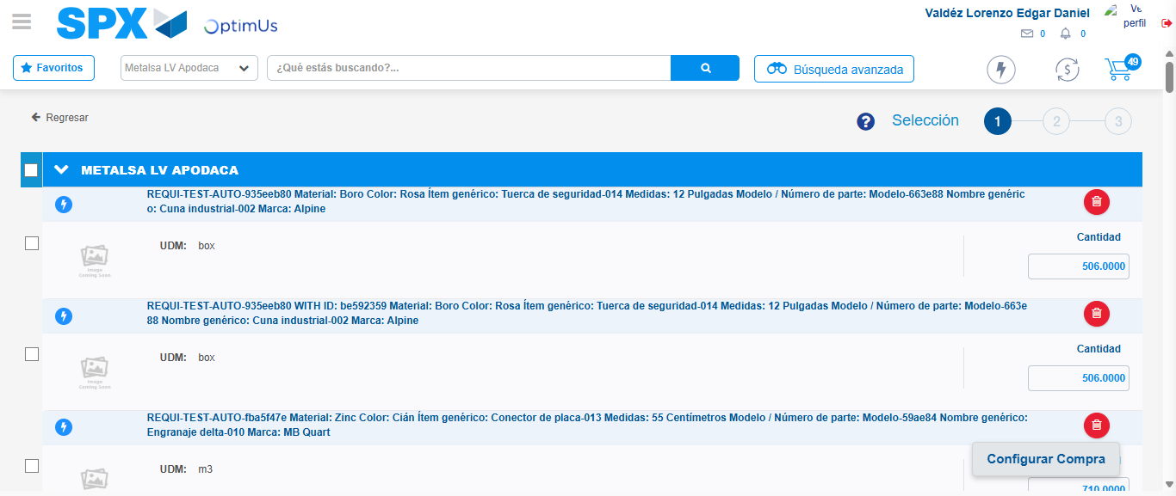Image file-name: QC_Testing-tc001_SPX_Dev5_Crear_Nueva_Linea_Requisicion_Spot_Tipo_Cobro_CC-1781314628437

Image file-name: QC_Testing-tc001_SPX_Dev5_Crear_Nueva_Linea_Requisicion_Spot_Tipo_Cobro_CC-1781314628675

Image file-name: QC_Testing-tc001_SPX_Dev5_Crear_Nueva_Linea_Requisicion_Spot_Tipo_Cobro_CC-1781314628858

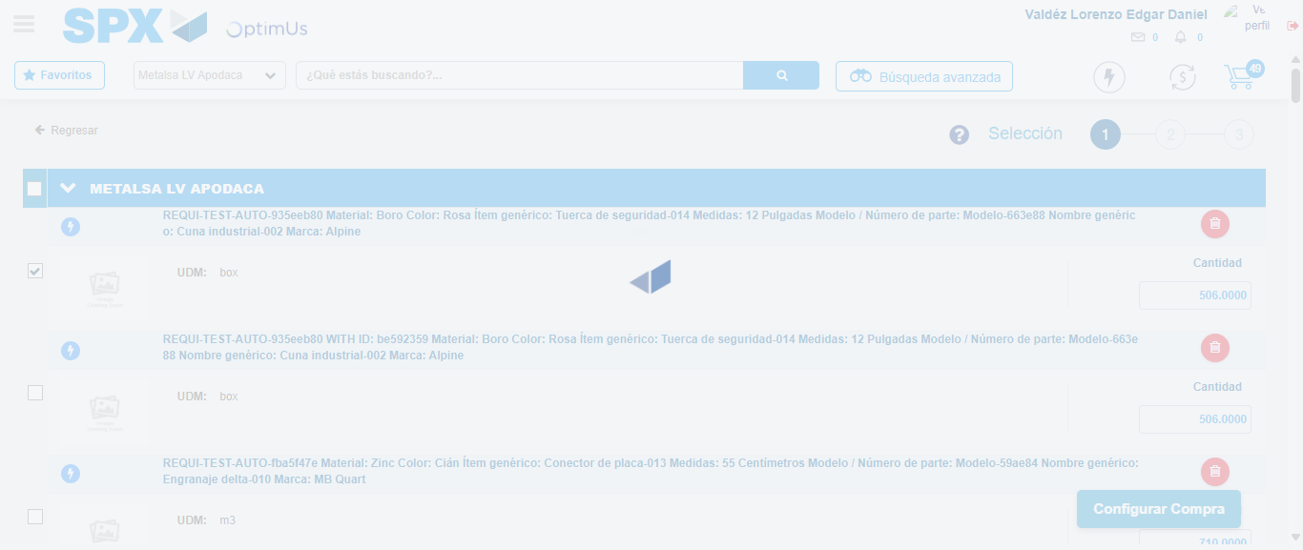Image file-name: QC_Testing-tc001_SPX_Dev5_Crear_Nueva_Linea_Requisicion_Spot_Tipo_Cobro_CC-1781314629729

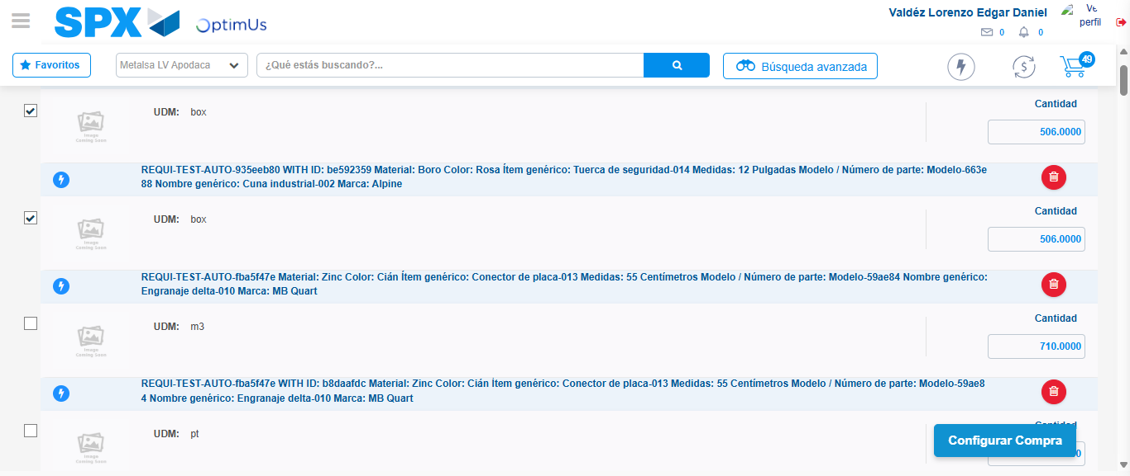Image file-name: QC_Testing-tc001_SPX_Dev5_Crear_Nueva_Linea_Requisicion_Spot_Tipo_Cobro_CC-1781314631651

Step 6 - Select Type Account For Requisition: Type Account Correctly selected
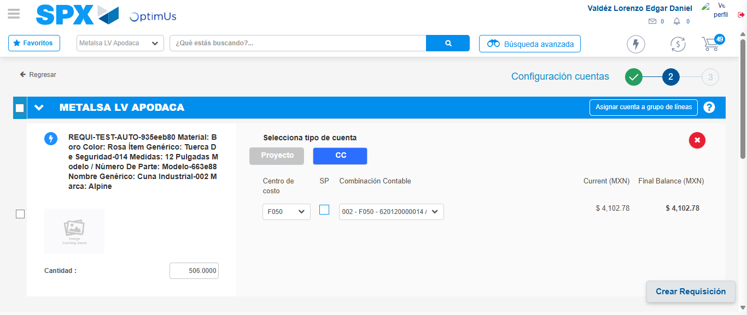Image file-name: QC_Testing-tc001_SPX_Dev5_Crear_Nueva_Linea_Requisicion_Spot_Tipo_Cobro_CC-1781314642884

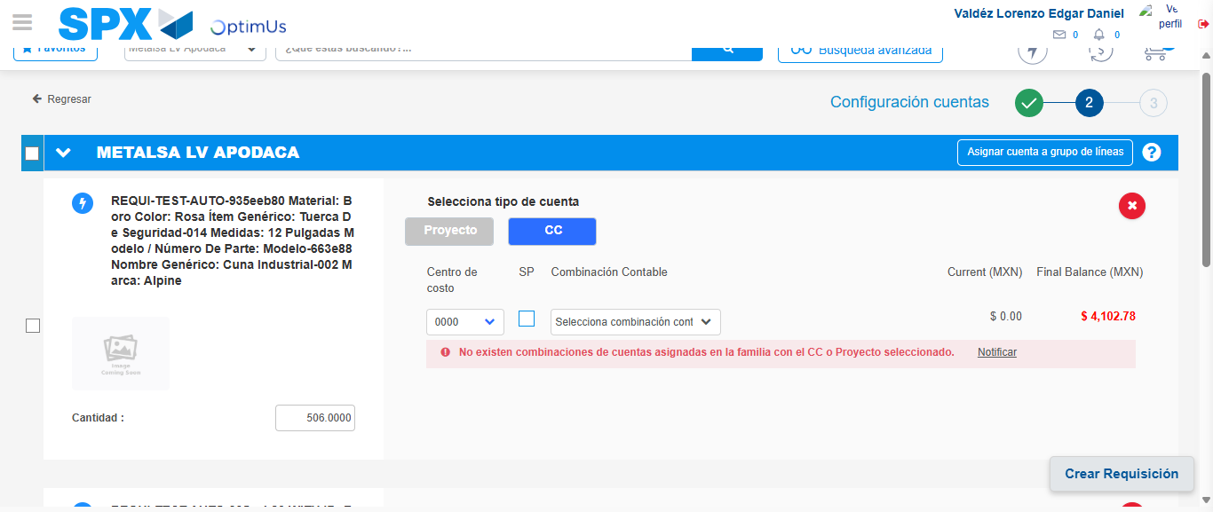Image file-name: QC_Testing-tc001_SPX_Dev5_Crear_Nueva_Linea_Requisicion_Spot_Tipo_Cobro_CC-1781314653907

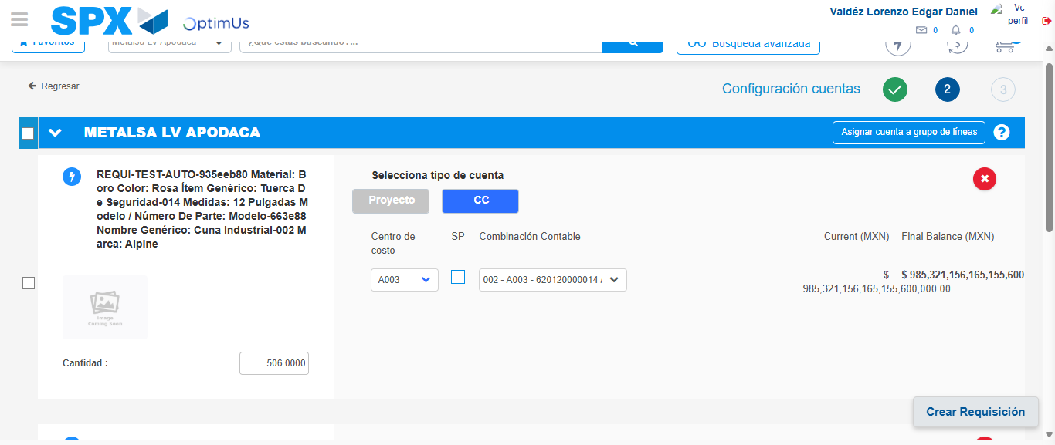Image file-name: QC_Testing-tc001_SPX_Dev5_Crear_Nueva_Linea_Requisicion_Spot_Tipo_Cobro_CC-1781314661813

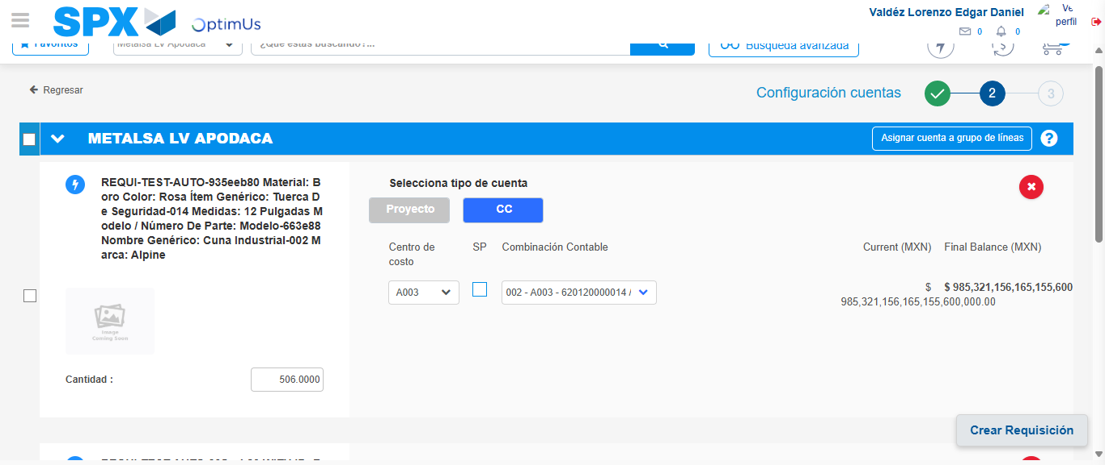Image file-name: QC_Testing-tc001_SPX_Dev5_Crear_Nueva_Linea_Requisicion_Spot_Tipo_Cobro_CC-1781314664618

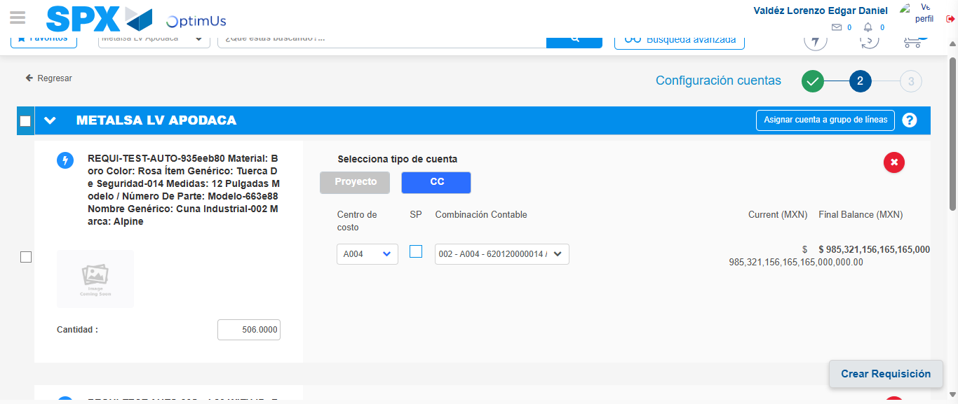Image file-name: QC_Testing-tc001_SPX_Dev5_Crear_Nueva_Linea_Requisicion_Spot_Tipo_Cobro_CC-1781314672267

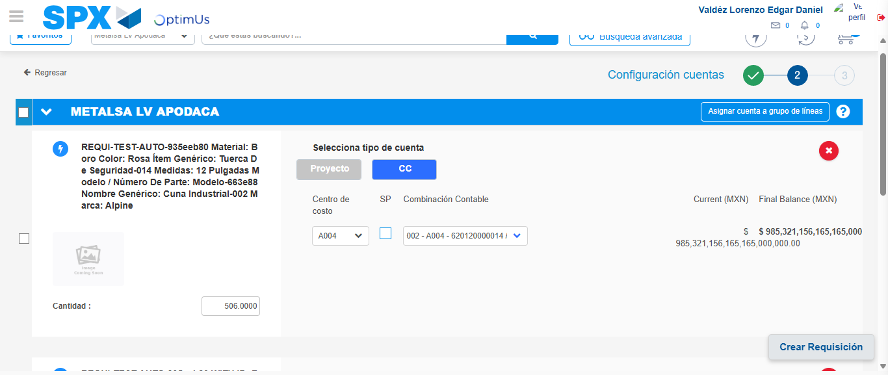Image file-name: QC_Testing-tc001_SPX_Dev5_Crear_Nueva_Linea_Requisicion_Spot_Tipo_Cobro_CC-1781314674892

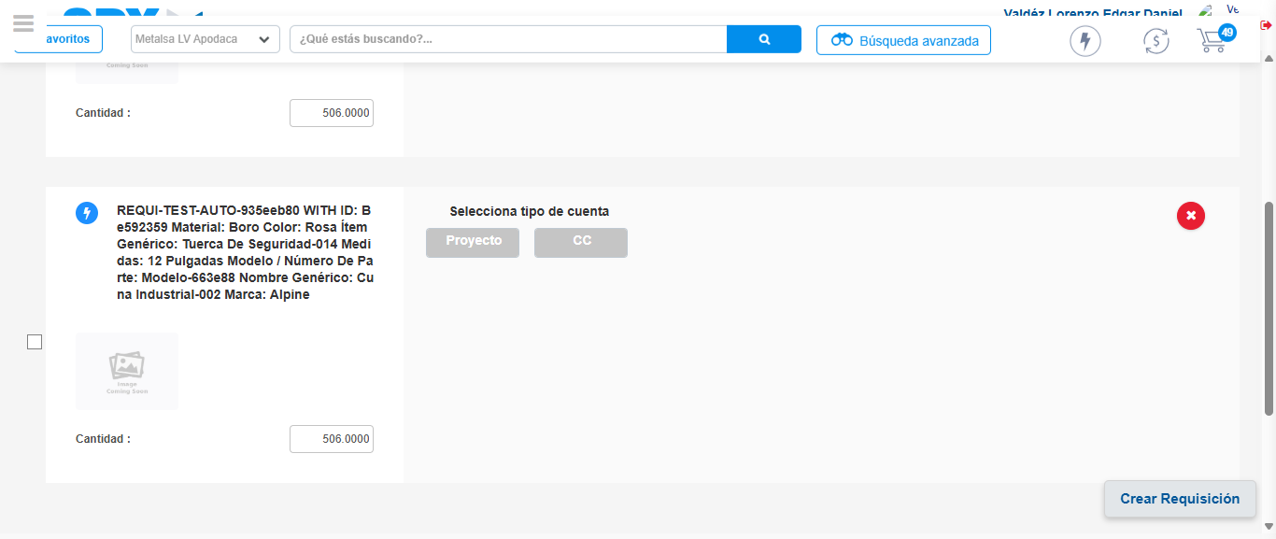Image file-name: QC_Testing-tc001_SPX_Dev5_Crear_Nueva_Linea_Requisicion_Spot_Tipo_Cobro_CC-1781314682573

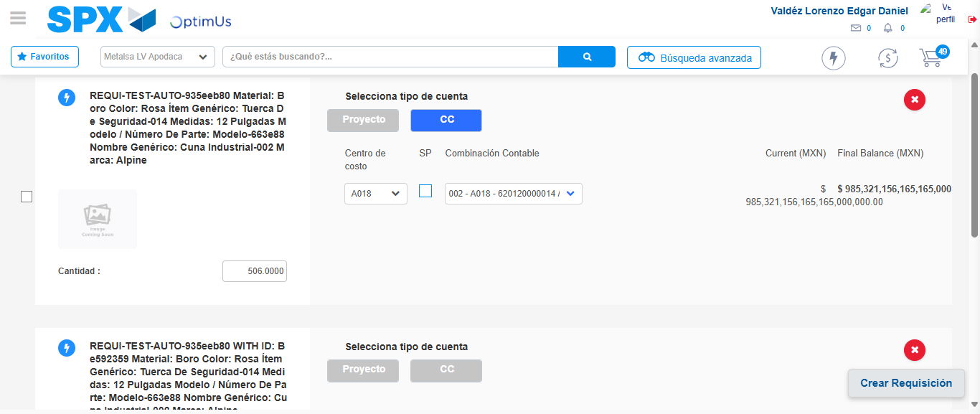Image file-name: QC_Testing-tc001_SPX_Dev5_Crear_Nueva_Linea_Requisicion_Spot_Tipo_Cobro_CC-1781314685253

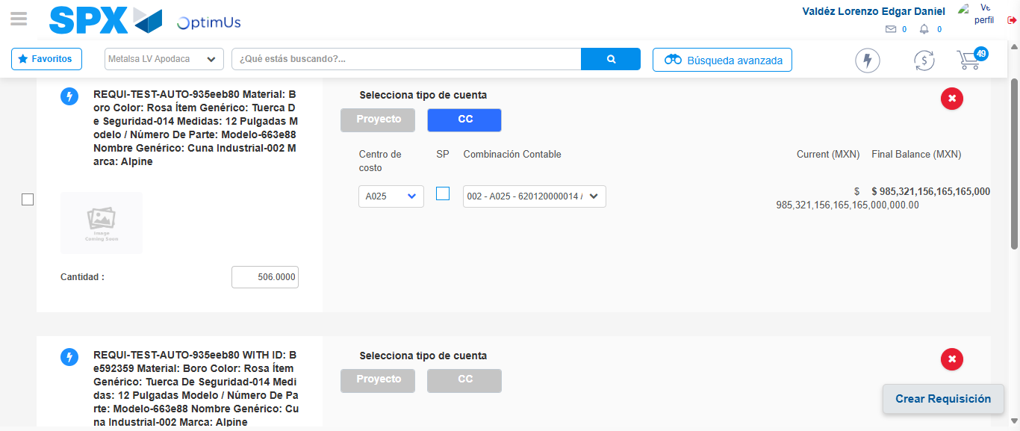Image file-name: QC_Testing-tc001_SPX_Dev5_Crear_Nueva_Linea_Requisicion_Spot_Tipo_Cobro_CC-1781314692349

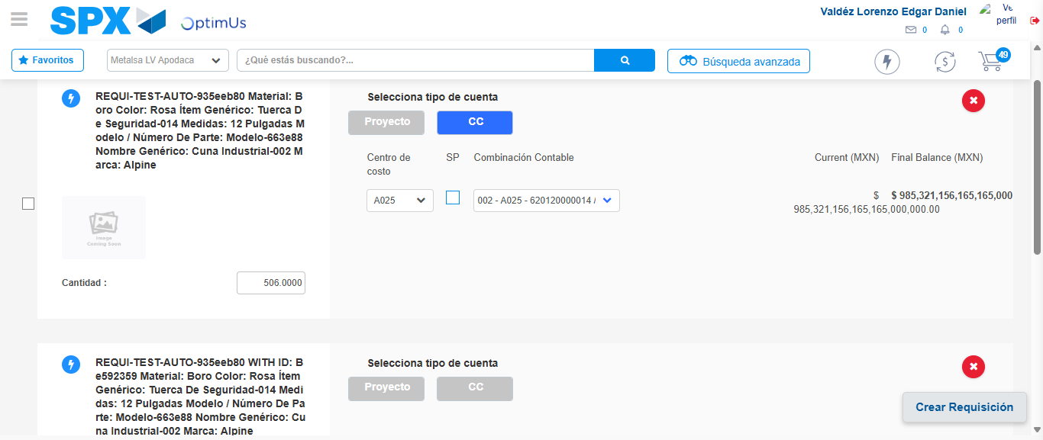Image file-name: QC_Testing-tc001_SPX_Dev5_Crear_Nueva_Linea_Requisicion_Spot_Tipo_Cobro_CC-1781314695105

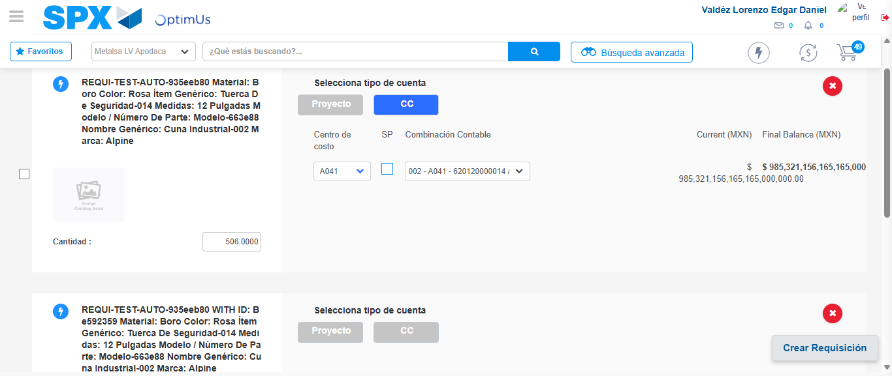Image file-name: QC_Testing-tc001_SPX_Dev5_Crear_Nueva_Linea_Requisicion_Spot_Tipo_Cobro_CC-1781314702857

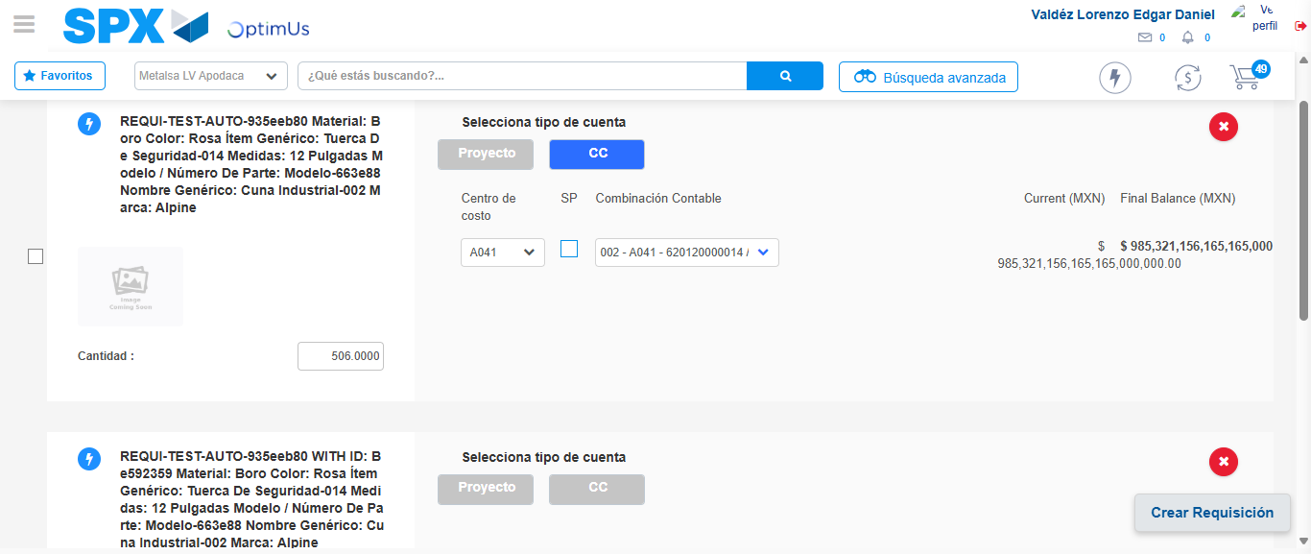Image file-name: QC_Testing-tc001_SPX_Dev5_Crear_Nueva_Linea_Requisicion_Spot_Tipo_Cobro_CC-1781314705495

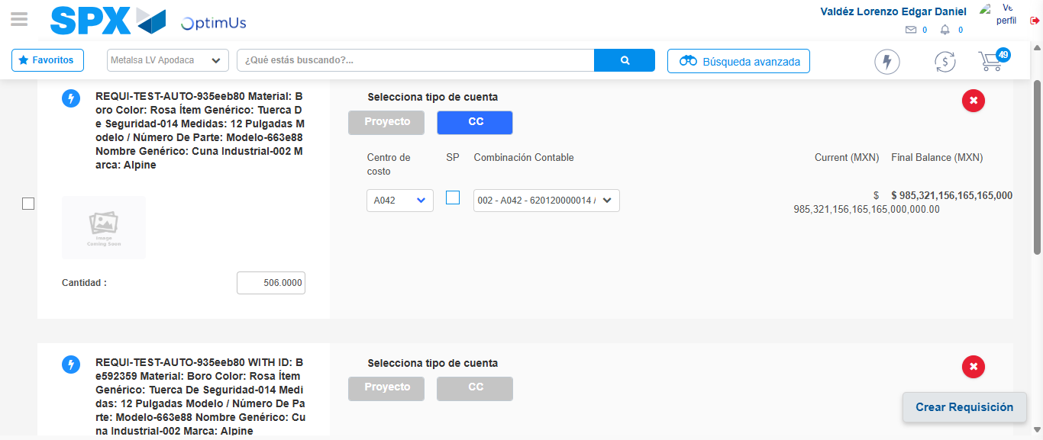Image file-name: QC_Testing-tc001_SPX_Dev5_Crear_Nueva_Linea_Requisicion_Spot_Tipo_Cobro_CC-1781314712668

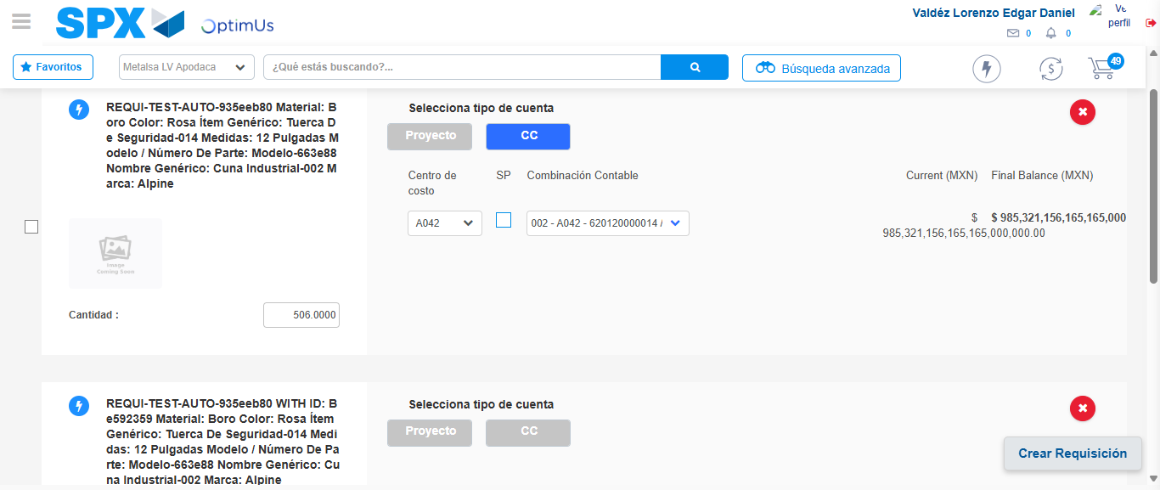Image file-name: QC_Testing-tc001_SPX_Dev5_Crear_Nueva_Linea_Requisicion_Spot_Tipo_Cobro_CC-1781314715464

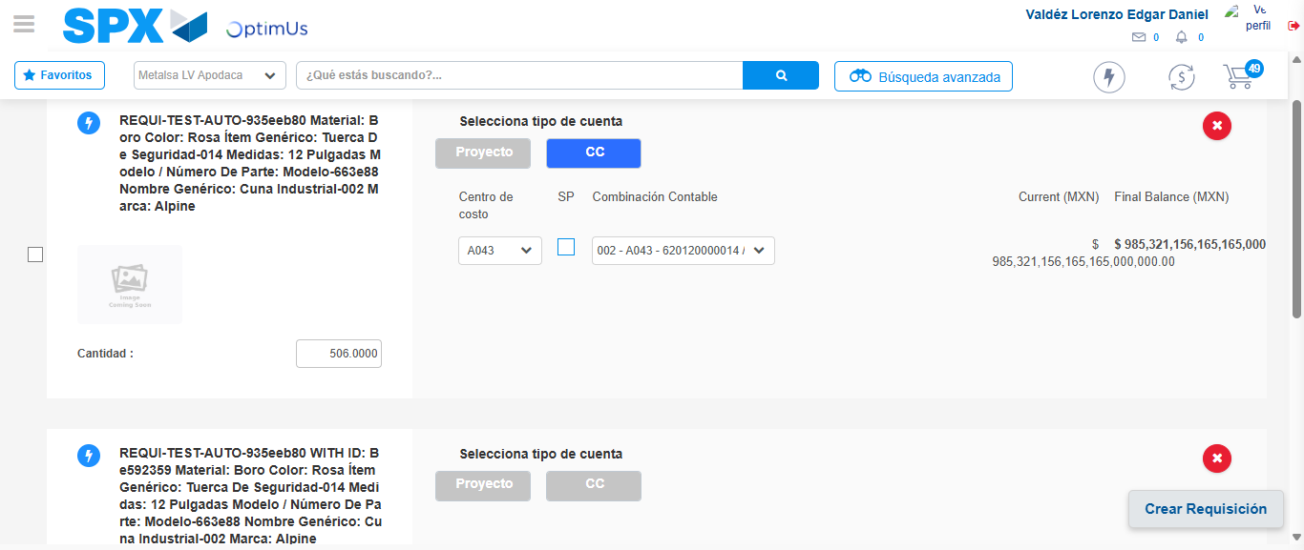Image file-name: QC_Testing-tc001_SPX_Dev5_Crear_Nueva_Linea_Requisicion_Spot_Tipo_Cobro_CC-1781314723201

Image file-name: QC_Testing-tc001_SPX_Dev5_Crear_Nueva_Linea_Requisicion_Spot_Tipo_Cobro_CC-1781314725839

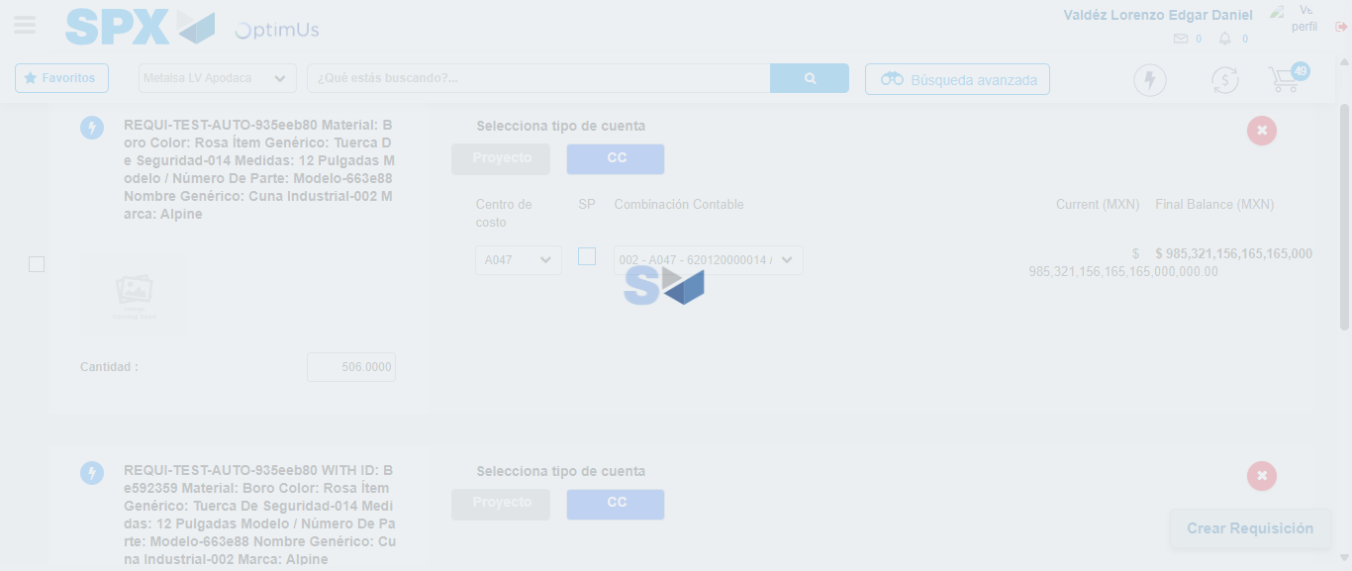Image file-name: QC_Testing-tc001_SPX_Dev5_Crear_Nueva_Linea_Requisicion_Spot_Tipo_Cobro_CC-1781314733502

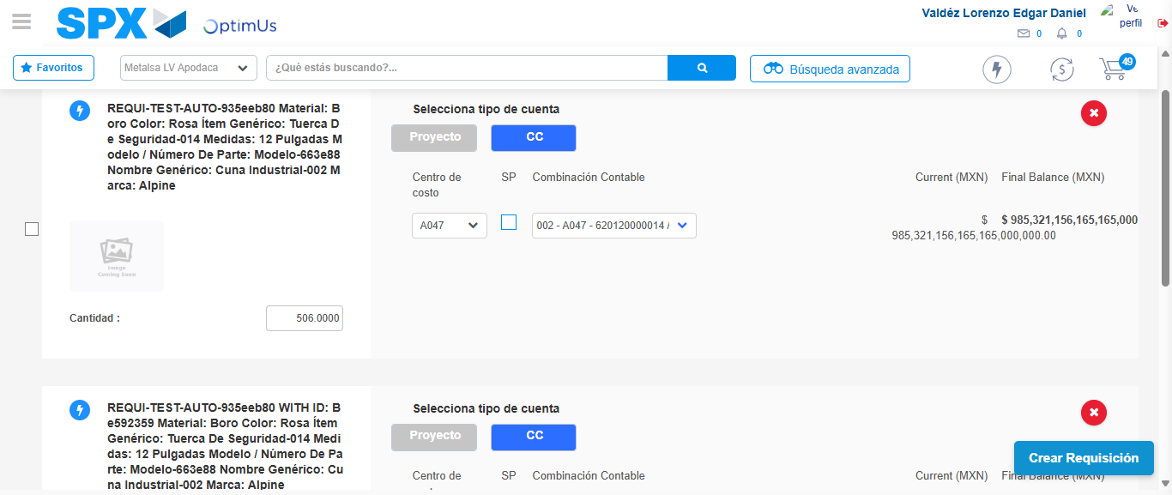Image file-name: QC_Testing-tc001_SPX_Dev5_Crear_Nueva_Linea_Requisicion_Spot_Tipo_Cobro_CC-1781314739309

Image file-name: QC_Testing-tc001_SPX_Dev5_Crear_Nueva_Linea_Requisicion_Spot_Tipo_Cobro_CC-1781314741615

Image file-name: QC_Testing-tc001_SPX_Dev5_Crear_Nueva_Linea_Requisicion_Spot_Tipo_Cobro_CC-1781314741850

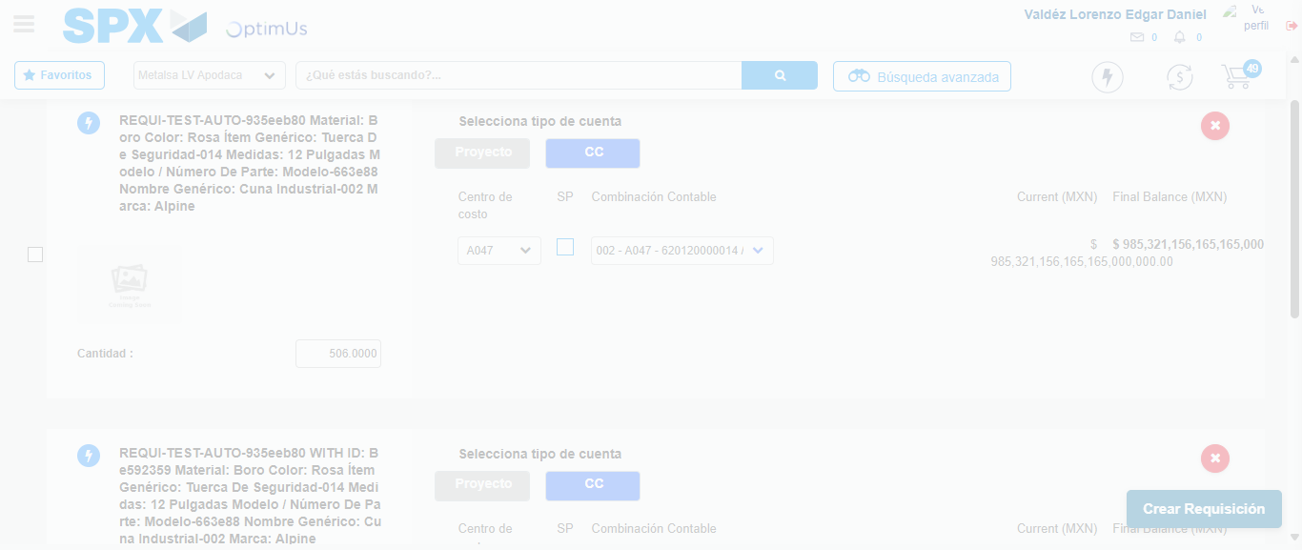Image file-name: QC_Testing-tc001_SPX_Dev5_Crear_Nueva_Linea_Requisicion_Spot_Tipo_Cobro_CC-1781314742319

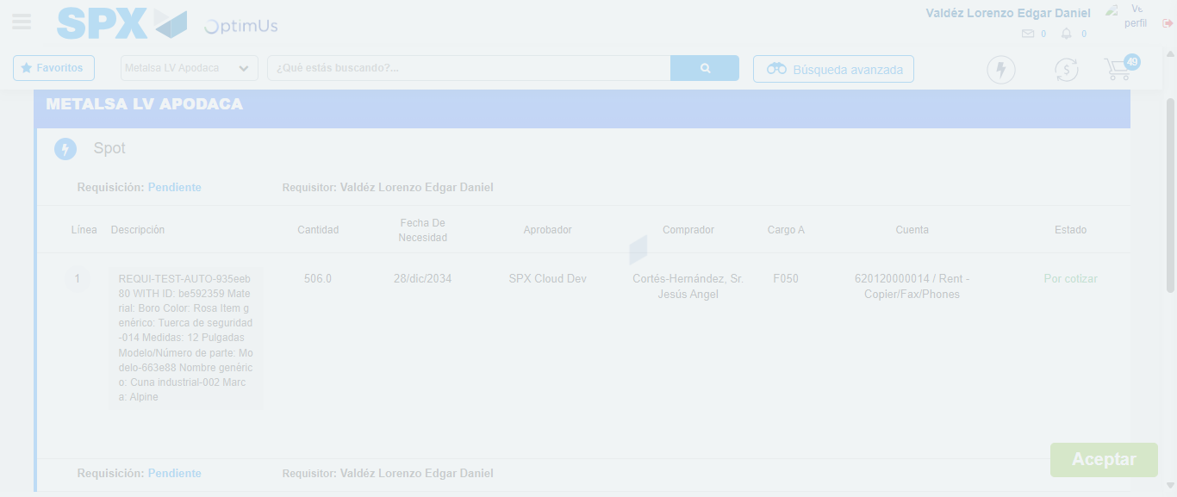Image file-name: QC_Testing-tc001_SPX_Dev5_Crear_Nueva_Linea_Requisicion_Spot_Tipo_Cobro_CC-1781314742552

Step 7 - Accept to Requisition: Requisition Accepted
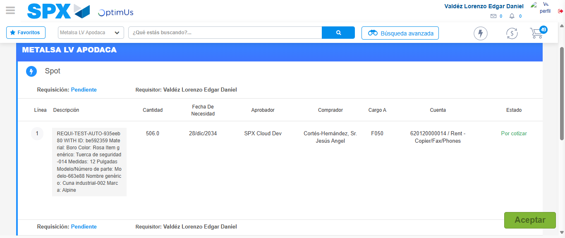Image file-name: QC_Testing-tc001_SPX_Dev5_Crear_Nueva_Linea_Requisicion_Spot_Tipo_Cobro_CC-1781314743349

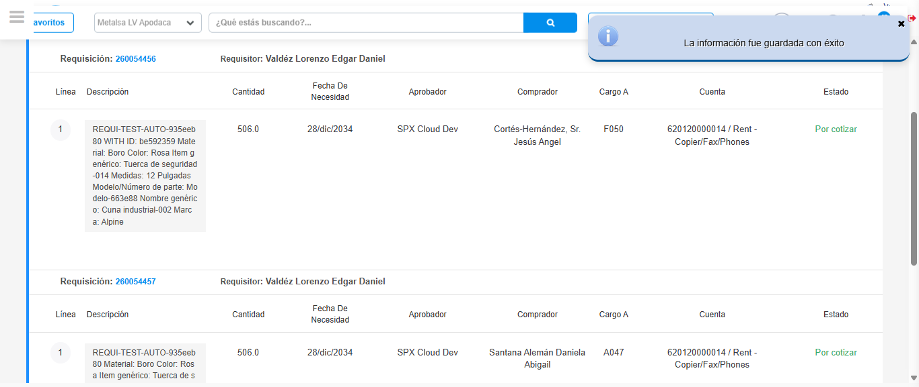Image file-name: QC_Testing-tc001_SPX_Dev5_Crear_Nueva_Linea_Requisicion_Spot_Tipo_Cobro_CC-1781314745775

Step 8 - Return to Main Page SPX : Return to Main Page SPX
Image file-name: QC_Testing-tc001_SPX_Dev5_Crear_Nueva_Linea_Requisicion_Spot_Tipo_Cobro_CC-1781314546574

Image file-name: QC_Testing-tc001_SPX_Dev5_Crear_Nueva_Linea_Requisicion_Spot_Tipo_Cobro_CC-1781314549136

Image file-name: QC_Testing-tc001_SPX_Dev5_Crear_Nueva_Linea_Requisicion_Spot_Tipo_Cobro_CC-1781314585667

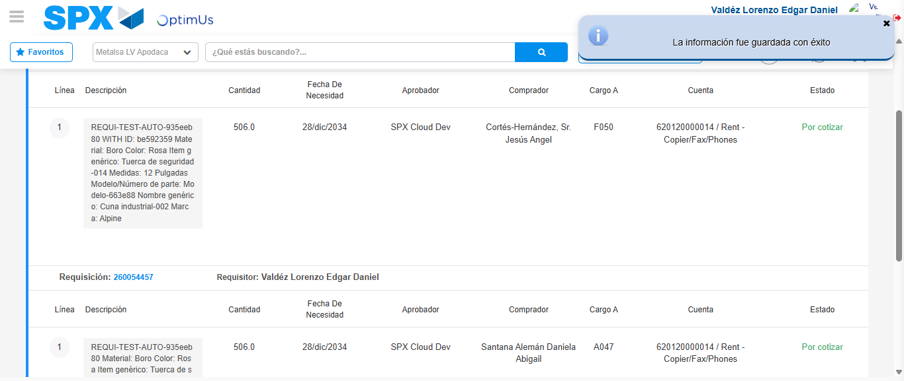Image file-name: QC_Testing-tc001_SPX_Dev5_Crear_Nueva_Linea_Requisicion_Spot_Tipo_Cobro_CC-1781314748032

Image file-name: QC_Testing-tc001_SPX_Dev5_Crear_Nueva_Linea_Requisicion_Spot_Tipo_Cobro_CC-1781314748215

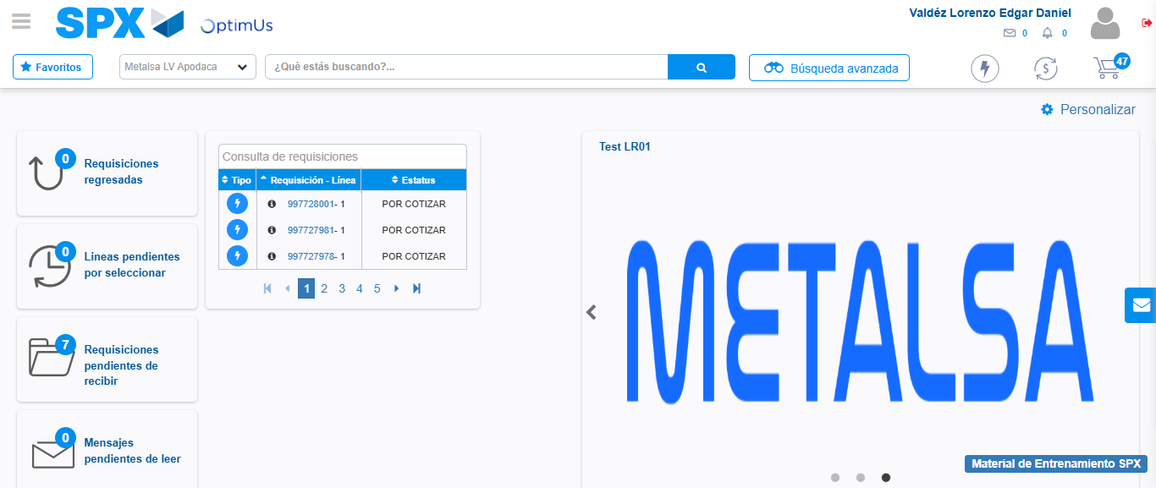Image file-name: QC_Testing-tc001_SPX_Dev5_Crear_Nueva_Linea_Requisicion_Spot_Tipo_Cobro_CC-1781314769520

Step 9 - Log Out : Log Out SPX
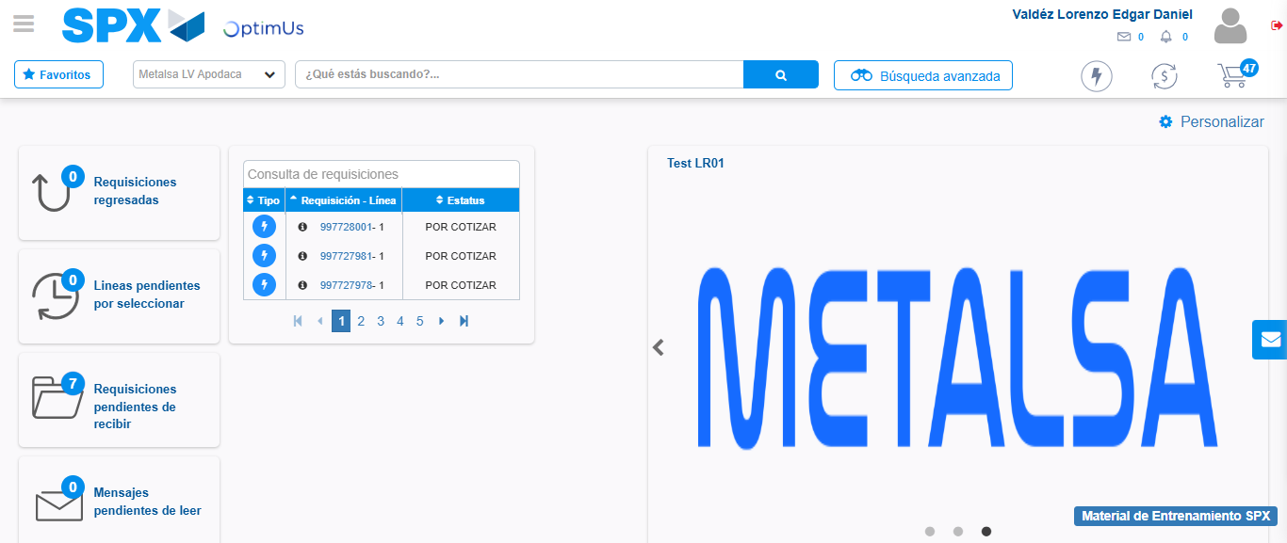Image file-name: QC_Testing-tc001_SPX_Dev5_Crear_Nueva_Linea_Requisicion_Spot_Tipo_Cobro_CC-1781314769817

